What Is AWS?

Cloud computing is the on-demand delivery of IT resources with primarily pay-as-you-go pricing.

Cloud Computing Deployment Models
- On-Premises

- Everything (servers, storage, networking) is kept inside the company.
- The company is responsible for buying, managing, and maintaining all hardware.
- This is expensive and requires a lot of effort.
👉 Think of it like owning and maintaining your own computer system at home.

- Cloud

- Resources are provided over the internet.
- Companies like Amazon Web Services manage the hardware.
- You only pay for what you use.
- No need to worry about maintenance.
👉 Like using online services instead of owning physical equipment.

- Hybrid

- A combination of both on-premises and cloud.
- Some resources stay in the company, while others are in the cloud.
- They are connected and work together.
👉 Like keeping some files on your computer and others in cloud storage.

• On-Premises: Full control, but costly and hard to manage
• Cloud: Easy, flexible, and cost-effective
• Hybrid: Mix of both for better flexibility

Six Advantages of cloud computing

- Pay-as-you-go
We have to pay only for the resources we are using instead of investing on expensive hardware.

- Economies of Scale
Cloud providers reduce costs by serving many users, making services cheaper.

- Stop guessing capacity
Scale resources up or down anytime without overpaying or running out.

- Increase speed and agility
Access IT resources quickly in minutes , speeding up development and experimentation.

- Cost savings
Avoid managing data centers and focus on core business activities.

- Go global in minutes
Deploy applications worldwide quickly for better performance and reach.

AWS Global Infrastructure

- Storing data in the cloud (like AWS) keeps it safe and accessible from anywhere.
- AWS uses redundancy (multiple copies) to protect data from failures or disasters.

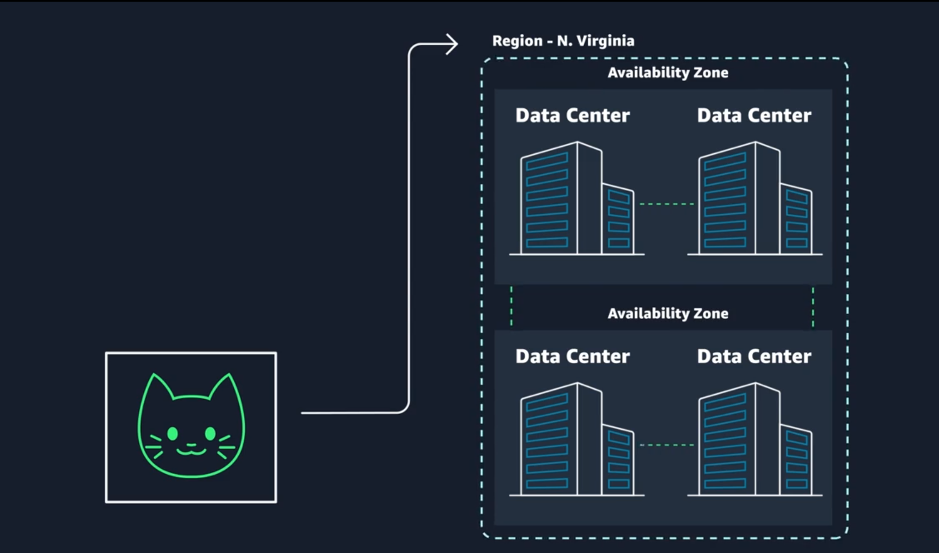

Key Components
- Data Centers
Physical buildings where servers and data are stored.
- Availability Zones (AZs)
One or more data centers grouped together with backup power and networking.
- Regions
Multiple AZs grouped in a geographic area (e.g., Northern Virginia).

Choosing an AWS Region

Consider these 4 factors:
- Compliance → Legal rules about where data must be stored, country allowance.
- Latency → Closer to users = faster performance
- Pricing → Costs vary by region
- Service Availability → Not all services are in every region

Edge Locations & Caching
- AWS uses edge locations to store (cache) content closer to users.
- This reduces latency and speeds up access worldwide.
- Services like Amazon CloudFront help deliver content faster.

AWS infrastructure uses data centers → AZs → Regions with redundancy, and edge locations for faster global access, ensuring reliability and low latency.

Regions

Regions are geographic locations worldwide where AWS hosts its data centers. AWS Regions are named after the location where they reside.

- us-east-1 is the first Region created in the eastern US area. The geographical name for this Region is N. Virginia.
- ap-northeast-1 is the first Region created in the northeast Asia Pacific area. The geographical name for this Region is Tokyo.

Within AWS console, we can select a available region from the dropdown menu.

Without explicit customer consent and authorization, data is not replicated from one Region to another.

Availability Zones

Inside every Region is a cluster of Availability Zones. An Availability Zone consists of one or more data centers with redundant power, networking, and connectivity. These data centers operate in discrete facilities in undisclosed locations. They are connected using redundant high-speed and low-latency links.

Availability Zones also have code names. Because they are located inside Regions.

- us-east-1a is an Availability Zone in us-east-1 (N. Virginia Region).
- sa-east-1b is an Availability Zone in sa-east-1 (São Paulo Region).

if you see that a resource exists in us-east-1c, you can infer that the resource is located in Availability Zone c of the us-east-1 Region.

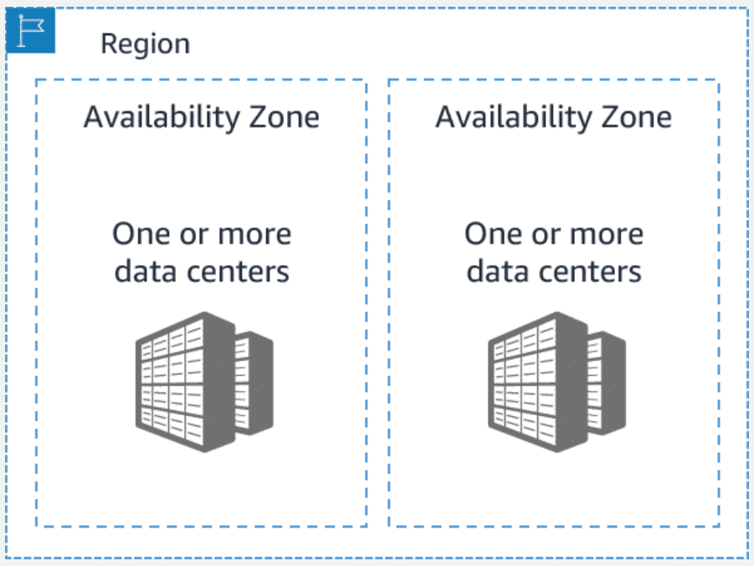

Availability Zones (AZs)
- A Region contains multiple AZs, and each AZ has one or more data centers.
- AZs have backup power, networking, and connections for reliability.
- They are identified by adding a letter (e.g., us-east-1a).

Scope of AWS Services
- Region-level services: You only choose a Region; AWS handles availability.
- AZ-level services: You choose specific AZs and manage availability yourself.

Maintaining Resiliency
- Use multiple AZs (at least two) to keep applications running if one fails.
- Region-based managed services are more reliable by default.

Edge Locations
- Global locations that cache content closer to users.
- This reduces delay (latency) and improves speed.
- Amazon CloudFront uses edge locations to deliver content quickly worldwide.

Every action that you make in AWS is an API call that is authenticated and authorized.

Interacting wit AWS :

In cloud computing, you don’t physically manage servers—you control them using the AWS API.

Three Ways to Use AWS:

- AWS Management Console
A web-based interface where you can click and create resources easily (best for beginners).
- AWS Command Line Interface (CLI)
A text-based tool where you run commands to create and manage resources (faster and reduces errors).
- AWS Software Development Kits (SDKs)
Tools for programming languages (like Python, Java) to interact with AWS in your code.

Key Idea
- Console = easy but manual
- CLI = faster and repeatable
- SDKs = powerful and automated

You interact with AWS using API calls through Console (easy), CLI (efficient), or SDKs (programmable).

Security and the AWS Shared Responsibility Model :

AWS Shared Responsibility Model (Summary)
- Security in AWS is shared between you and AWS.

AWS Responsibility (Security of the Cloud)
- Protects physical data centers and hardware
- Secures networking and global infrastructure
- Manages host OS, virtualization, and core services (e.g., Amazon EC2 infrastructure)

Your Responsibility (Security in the Cloud)
- Manage and secure your data
- Control user access and permissions
- Configure firewalls and encryption
- Update and patch your operating systems

Key Idea
- AWS secures the foundation
- You secure what you build on top of it

In One Line
AWS handles security of the cloud, while you handle security in the cloud, together ensuring a secure environment.

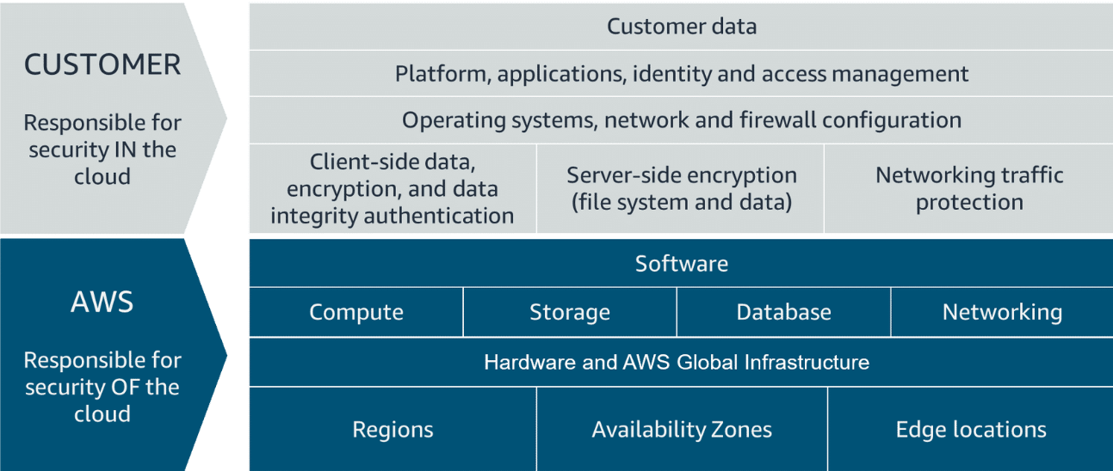

AWS responsibility

AWS is responsible for security of the cloud.
- Protecting and securing AWS Regions, Availability Zones, and data centers, down to the physical security of the buildings
- Managing the hardware, software, and networking components that run AWS services, such as the physical servers, host operating systems, virtualization layers, and AWS networking components

The level of responsibility that AWS has depends on the service.

Customer responsibility

Customers are responsible for security in the cloud.

When using any AWS service, the customer is responsible for properly configuring the service and their applications, in addition to ensuring that their data is secure.

The customers' level of responsibility depends on the AWS service. Some services require the customer to perform all the necessary security configuration and management tasks. Other more abstracted services require customers to only manage the data and control access to their resources.

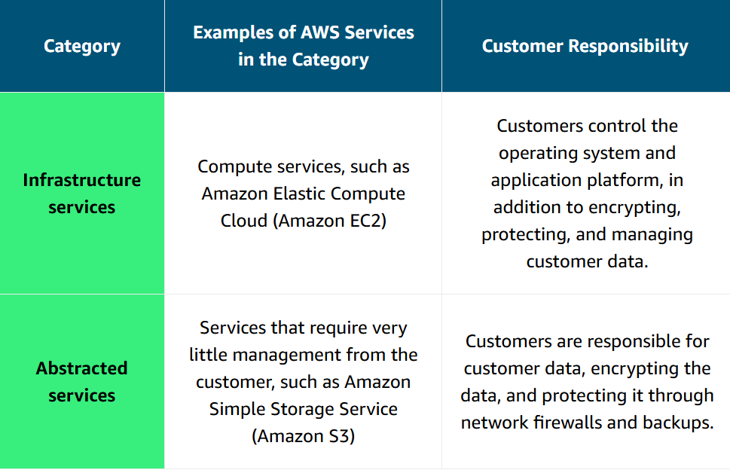

Protecting the AWS Root User

AWS Root User & Security (Summary)
- The root user (created with your email and password) has full access to everything in your AWS account.
- Because it’s very powerful, it must be protected carefully.

Best Security Practices
- Enable Multi-Factor Authentication (MFA)
  - Adds an extra security step (like a one-time code).
  - Even if someone knows your password, they can’t log in without MFA.
- Use a strong password
  - Prevents easy access through guessing or hacking.
- Avoid using root user daily
  - Use other users (like IAM users) for regular tasks.

Key Idea
- Root user = full control → high risk if compromised

In One Line
Protect the AWS root user by enabling MFA, using strong passwords, and avoiding daily use to prevent unauthorized access.

AWS Root User (Overview)
- The root user is the first account created and has full access to everything in AWS.
- It uses email + password to log in.

Root User Credentials
- Email & Password → Used for logging into the console
- Access Keys → Used for programmatic access (CLI/API)
  - Access Key ID
  - Secret Access Key
⚠️ These must be kept very secure.

Best Practices to Protect Root User
- Use a strong password
- Enable Multi-Factor Authentication (MFA)
- Never share credentials
- Delete/avoid access keys for root user
- Do not use root user for daily tasks
- Create IAM users for regular use

Multi-Factor Authentication (MFA)
- Requires two or more verification methods:
  - Something you know (password)
  - Something you have (OTP device/app)
  - Something you are (biometric)
- Adds an extra layer of security → even if password is hacked, account stays safe.

Types of MFA Devices
- Virtual MFA apps (e.g., mobile authenticator apps)
- Hardware tokens (generate codes)
- FIDO security keys (USB-based devices)

Key Idea
- Root user = most powerful → must be most protected

In One Line
Secure the AWS root user by using strong credentials, enabling MFA, avoiding access keys, and using IAM users instead.

Authentication vs Authorization
- Authentication → Verifies who you are (login with username/password, etc.)
- Authorization → Determines what you can do (permissions like read, write, delete)

IAM (Identity and Access Management)
- A service that manages access to AWS accounts and resources
- Controls both authentication and authorization
- Lets you give secure, limited access without sharing passwords

IAM Features
- Global service (works across all Regions)
- Integrated with AWS services
- Supports MFA for extra security
- Allows shared access and identity federation
- Free to use

IAM Components
- IAM Users
  - Individual identities with login credentials
  - Used by people or services
- IAM Groups
  - Collection of users with shared permissions
  - Best practice: assign permissions to groups
- IAM Policies
  - JSON rules that allow or deny actions
  - Define:
    - Effect (Allow/Deny)
    - Action (what can be done)
    - Resource (where it applies)

Key Idea
- IAM helps you securely control access by defining who can access AWS and what they can do

In One Line
Authentication verifies identity, authorization controls permissions, and IAM manages both to secure AWS access.

IAM Role Creation (for Application)
- Created a role for an app running on Amazon EC2
- Selected AWS service → EC2 as the trusted entity
- Attached permissions for:
  - Amazon S3 (storage)
  - Amazon DynamoDB (database)
- Role allows EC2 to securely access AWS services using temporary credentials

IAM User Creation
- Created a user (EC2Admin) with console access
- Added user to a group (EC2Admins)
- Group assigned EC2 full access policy
- Best practice: assign permissions to groups, not directly to users

Access Keys (Programmatic Access)
- Access keys = Access Key ID + Secret Access Key
- Used for CLI, SDKs, and API access
- Should be secured and not overused

Key Concepts
- Roles → Temporary access for services (like EC2 → S3)
- Users → Permanent identities for people
- Groups → Manage permissions efficiently
- Policies → Define what actions are allowed/denied

Security Reminder
- Prefer roles over access keys when possible
- Deactivate/delete unused keys

In One Line
IAM roles provide temporary secure access for services, while users, groups, and policies manage human access and permissions in AWS.

Hosting an Application with EC2 (Summary)
- The employee directory app is hosted using Amazon EC2 (virtual machines).

Key Steps
- Launch EC2 Instance
  - Choose Linux AMI and free-tier instance (t2.micro)
  - Name the instance (e.g., employee-web-app)
- Use Default Network
  - AWS provides a default VPC (private network)
  - Makes setup easier for beginners
- Configure Security
  - Create a security group (firewall)
  - Allow HTTP & HTTPS traffic
- Attach IAM Role
  - Assign role so EC2 can access other AWS services securely
- Use User Data Script
  - Automatically installs and runs the application on startup

Result
- Instance launches → app runs automatically → access via public IP
- Initially shows basic page (no database data yet)

Key Idea
- EC2 lets you quickly launch and run applications using virtual servers

In One Line
An application is deployed by launching an EC2 instance in a default VPC, configuring security and roles, and using a startup script to run it automatically.

EC2 – Elastic Compute Cloud

web service that provides secure, resizable compute capacity in the cloud.
Note : When architecting any application for high availability, consider using at least two EC2 instances in two separate Availability Zones.

Amazon EC2 (Overview)
- Amazon EC2 provides virtual servers (instances) in the cloud.
- You can launch, stop, and pay only for what you use.

Key Features
- Launch servers in minutes
- Flexible pricing (pay-as-you-go)
- Manage via Console, CLI, SDKs

EC2 Configuration
- Hardware → CPU, memory, storage, network
- Software → OS, firewall, authentication, networking

EC2 Image Builder
EC2 Image Builder is a fully managed AWS service that helps you to automate the creation, management, and deployment of customized, secure, and up-to-date server images

Amazon Machine Image (AMI)

Amazon Machine Image (AMI) is an image that provides the software that is required to set up and boot an Amazon EC2 instance.

- AMI = pre-configured template (OS + software)
- EC2 instance = running version of AMI
- AMIs are reusable → helps create identical servers quickly

Instance Types
- Define performance and capacity (CPU, memory, etc.)
- Example: c5n.xlarge
  - c = compute optimized
  - 5 = generation
  - n = extra features
  - xlarge = size

Instance Families
- General purpose → balanced workloads
- Compute optimized → heavy processing
- Memory optimized → large data handling
- Storage optimized → high I/O workloads
- Accelerated/HPC → advanced computing (ML, simulations)

Networking & Placement
- Instances run inside a VPC (network)
- Default VPC is easy for beginners but not ideal for sensitive data

High Availability
- Use multiple instances across different Availability Zones
- Prevents downtime if one instance fails

Key Idea

- EC2 gives you flexible, scalable virtual servers in the cloud

In One Line
Amazon EC2 lets you quickly launch scalable virtual servers using AMIs and instance types, with flexible pricing and high availability options.

EC2 Instance Lifecycle

An EC2 instance transitions between different states from the moment you create it until its termination.

